**Elemental Fox**

# Description

Elemental Fox is a 2D platformer and puzzle game where the player needs to resolve puzzles and avoid enemies by using different forms and powers.

The player can change the appearance and the abilities of the character during the gameplay by interacting with a elemental obelisk to complete the level.

The player can access 5 elemental forms (fire, water, earth, air and neutral) each element interacts in a different way with the traps and mechanisms, also every element has a active and a passive ability:

* Passive ability: Will interact with the environment just by being in a given place
* Active ability: Will be used when the player presses **“E”**

The player can also carry one single object to complete the puzzle while he caries a object the player can not use his active skill.

While the majority of the traps and mechanisms will either permit the player to pass, kill him or make him lose some progress, some of them may reveal hidden paths or present different challenges. The traps and mechanisms can also be specific for a element or have different variants for every element.

Enemies will need to be either avoided or used as steeping stones for the player to progress, with the combat being non existent instead the player needs to outsmart or completely avoid the enemies.

# Character

## Description

The general aspect of the character is that of a fox with two tails, with a black patch of fur at the end of each tail.

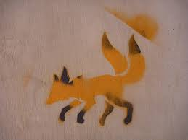

Changing the element causes the character to have a visible transformation, with every element having a different form that indicates to the player how the specific form can be used during the gameplay :

* Air - The lower part of the feet is missing/almost transparent gaining form and color towards the middle of the leg, giving the character a floaty aspect, with a higher jump ability and better control mid air
* Earth - Scales made of dirt appear on the body, concentrated around the shoulder, ribcage and on the head forming a helmet, making the character appear hard and sturdy as a rock, but also a slow mover.
* Fire - The end of the two tails and the ears light on fire, having a perpetual fire animation being played, making the character feel fast and agile
* Water - Fish tails will take the place of the usual tails, with the hole character having a melting feel, giving the player the feeling that the character can melt at any time, the character can use water streams to traverse the map.

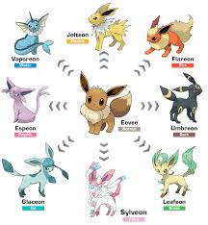

### General

### Fire

### Water

### Earth

### Air

### Neutral

## Abilities

### General

### Fire

### Water

### Earth

### Air

### Neutral

## Elemental Power

## Elemental Ability

## Controls

### Mouse and Keyboard

A/D - Left/Right

Space - Jump

E - Interact/Pick object/Active ability

### Controller

Left stick left/right - Left/Right

A - Jump

Y - Interact/Pick object/Active ability

# Camera

# Environment

## Theme

## Levels

## Enemies

## Mechanisms

## Traps

# Combat

## Health

# Economy

# Interface

## Start Menu

## UI

## Pause Menu

# Graphics and sound

## Graphics

## Sound